Rectilinear Shapes
# Source: AI Source: Provided by: [Data Path: Persons Table -> ID Column: 1, Name_En Column: Motasem Essam] -> From: [ChatGPT] on [7/25/2026]
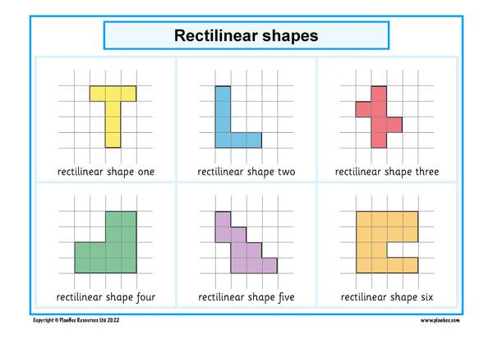
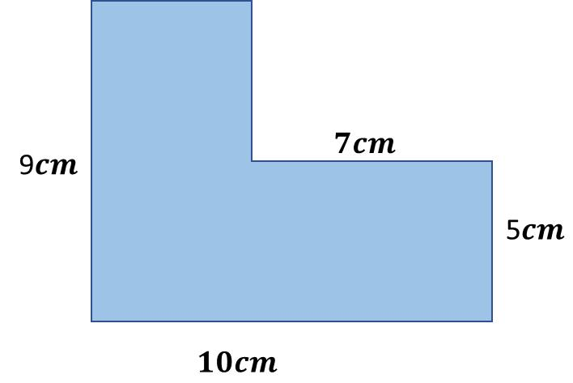
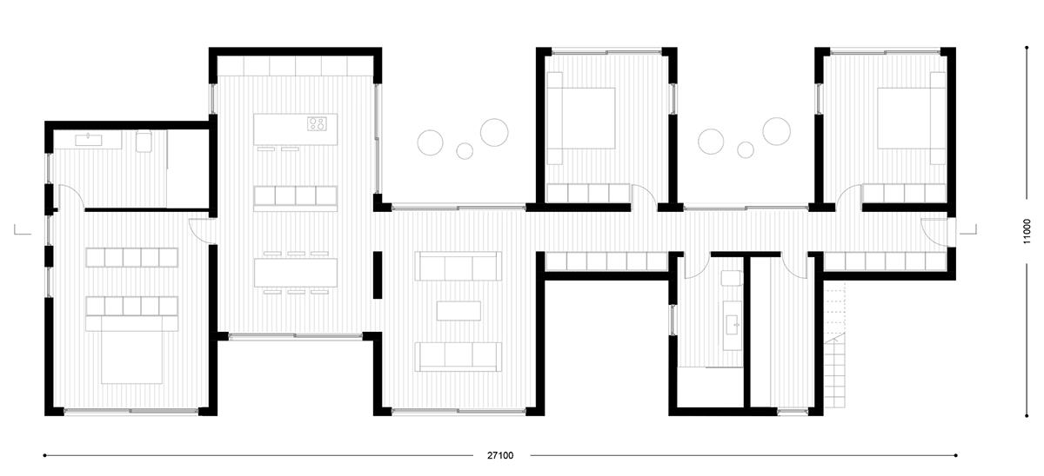
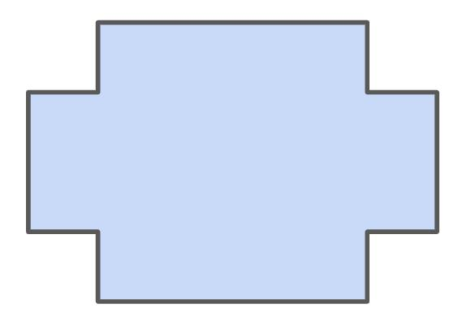
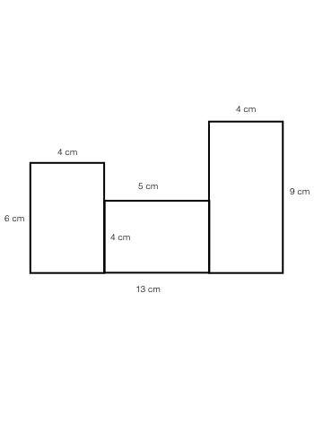

Definition
# Source: AI Source: Provided by: [Data Path: Persons Table -> ID Column: 1, Name_En Column: Motasem Essam] -> From: [ChatGPT] on [7/25/2026]
A Rectilinear Shape is a shape whose boundary is composed entirely of straight line segments that meet at right angles.
The segments are therefore aligned in a limited set of perpendicular directions, typically horizontal and vertical in a drawing.
For example:
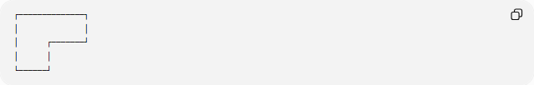
┌──────────────┐
│ │
│ ┌───────┘
│ │
└──────┘
A rectilinear shape may be regular or irregular, simple or complex, and convex or concave.

Fundamental Concept
# Source: AI Source: Provided by: [Data Path: Persons Table -> ID Column: 1, Name_En Column: Motasem Essam] -> From: [ChatGPT] on [7/25/2026]
The word rectilinear means formed by straight lines.
A rectilinear shape is distinguished not merely by having straight sides, but by the fact that its sides meet at right angles.
Thus:
$$\boxed{\text{Rectilinear Shape}=\text{Straight-Line Boundary}+\text{Right-Angle Turns}}$$
A rectangle is a simple example, but rectilinear shapes are not limited to rectangles.

Main Characteristics
# Source: AI Source: Provided by: [Data Path: Persons Table -> ID Column: 1, Name_En Column: Motasem Essam] -> From: [ChatGPT] on [7/25/2026]
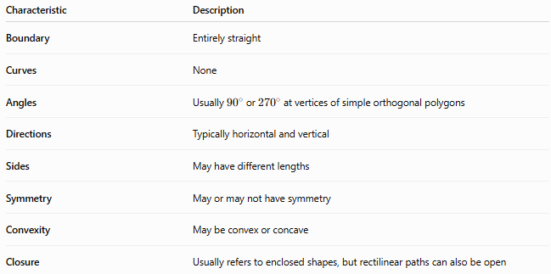
Characteristic | Description
Boundary | Entirely straight
Curves | None
Angles | Usually ${90}^{∘}$or ${270}^{∘}$at vertices of simple orthogonal polygons
Directions | Typically horizontal and vertical
Sides | May have different lengths
Symmetry | May or may not have symmetry
Convexity | May be convex or concave
Closure | Usually refers to enclosed shapes, but rectilinear paths can also be open

Basic Examples
# Source: AI Source: Provided by: [Data Path: Persons Table -> ID Column: 1, Name_En Column: Motasem Essam] -> From: [ChatGPT] on [7/25/2026]
Rectangle
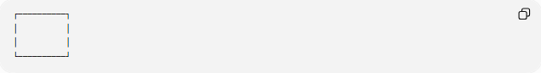
┌──────────┐
│ │
│ │
└──────────┘
A rectangle is a rectilinear shape because all four sides are straight and all four angles are right angles.
L-Shape
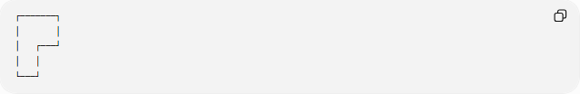
┌───────┐
│ │
│ ┌───┘
│ │
└───┘
This is also rectilinear even though it is not a rectangle.
T-Shape
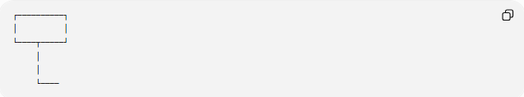
┌──────────┐
│ │
└────┬─────┘
│
│
└────
Its boundary consists entirely of horizontal and vertical segments.

Types of Rectilinear Shapes
# Source: AI Source: Provided by: [Data Path: Persons Table -> ID Column: 1, Name_En Column: Motasem Essam] -> From: [ChatGPT] on [7/25/2026]
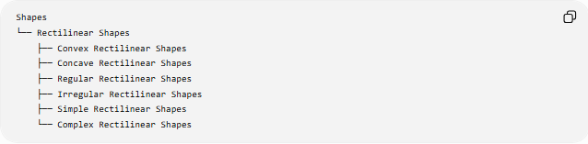
Shapes
└── Rectilinear Shapes
├── Convex Rectilinear Shapes
├── Concave Rectilinear Shapes
├── Regular Rectilinear Shapes
├── Irregular Rectilinear Shapes
├── Simple Rectilinear Shapes
└── Complex Rectilinear Shapes

1-Convex Rectilinear Shapes
# Source: AI Source: Provided by: [Data Path: Persons Table -> ID Column: 1, Name_En Column: Motasem Essam] -> From: [ChatGPT] on [7/25/2026]
A Convex Rectilinear Shape has no inward indentations.
Every interior angle is:
$${90}^{∘}$$
Example:
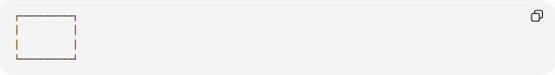
┌───────────┐
│ │
│ │
└───────────┘
A rectangle and square are convex rectilinear shapes.

2-Concave Rectilinear Shapes
# Source: AI Source: Provided by: [Data Path: Persons Table -> ID Column: 1, Name_En Column: Motasem Essam] -> From: [ChatGPT] on [7/25/2026]
A Concave Rectilinear Shape contains at least one inward indentation.
At an inward vertex, the interior angle is:
$${270}^{∘}$$
Example:
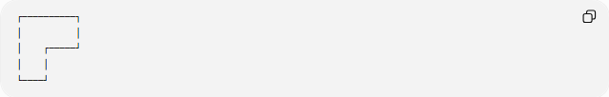
┌──────────┐
│ │
│ ┌─────┘
│ │
└────┘
Many L-shaped, T-shaped, and U-shaped figures are concave rectilinear shapes.
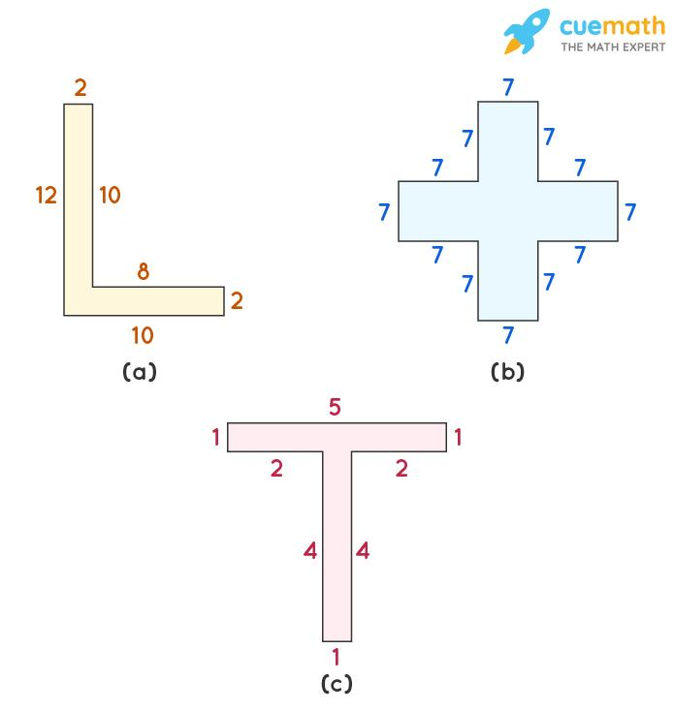
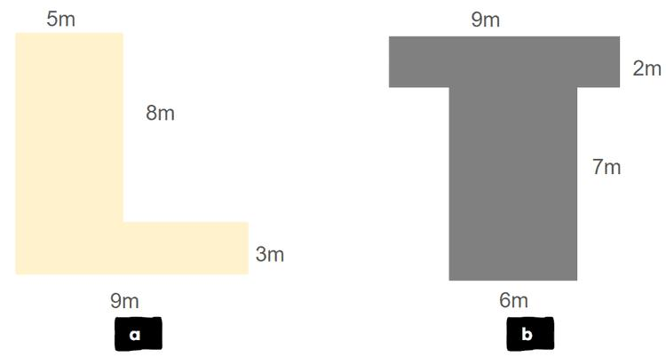
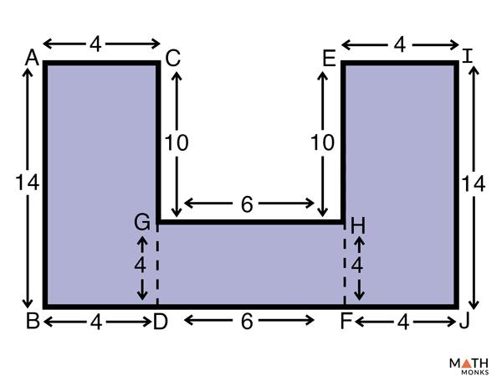
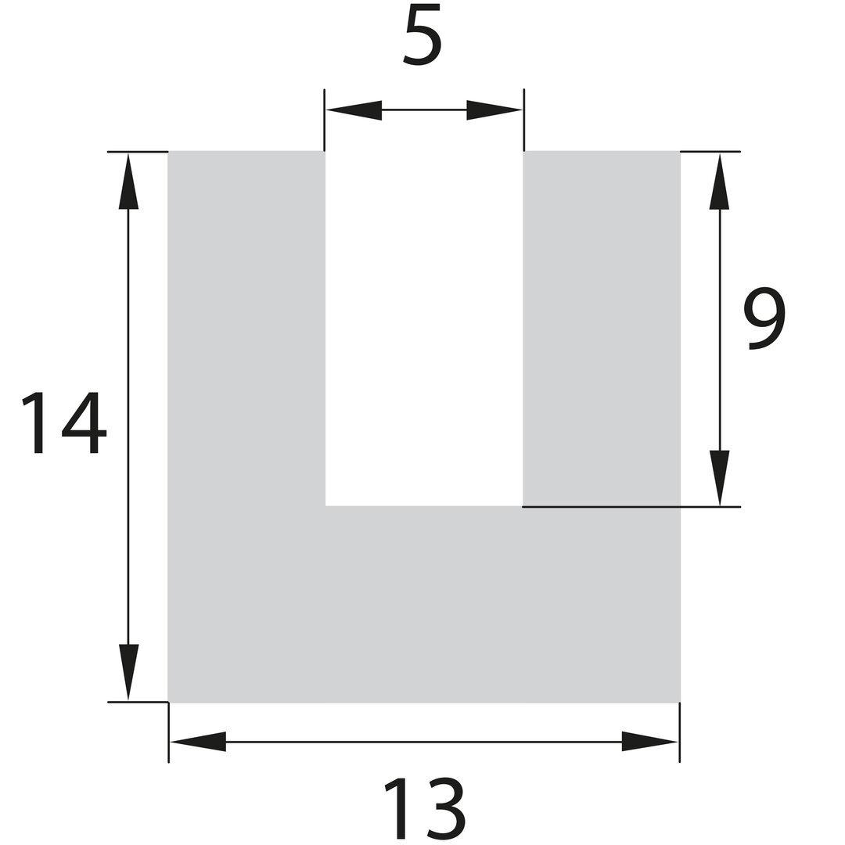
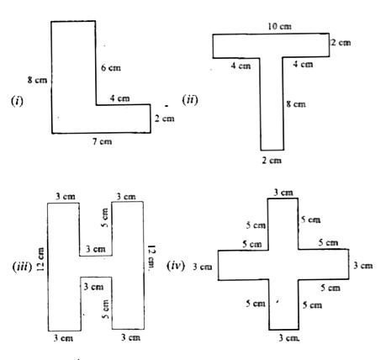
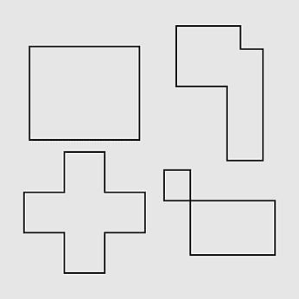

3-Regular Rectilinear Shapes
# Source: AI Source: Provided by: [Data Path: Persons Table -> ID Column: 1, Name_En Column: Motasem Essam] -> From: [ChatGPT] on [7/25/2026]
The term regular rectilinear shape is not generally a standard classification.
Among ordinary polygons, a square is the principal regular polygon that is also rectilinear:
- Four equal sides
- Four right angles
$$\boxed{\text{Square}=\text{Regular Polygon}+\text{Rectilinear Shape}}$$

4-Irregular Rectilinear Shapes
# Source: AI Source: Provided by: [Data Path: Persons Table -> ID Column: 1, Name_En Column: Motasem Essam] -> From: [ChatGPT] on [7/25/2026]
An Irregular Rectilinear Shape has straight horizontal and vertical sides but does not satisfy the conditions of a regular polygon.
Example:
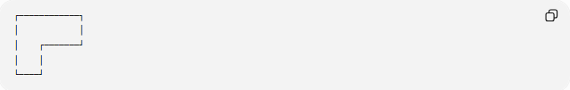
┌────────────┐
│ │
│ ┌───────┘
│ │
└────┘
Its sides can have different lengths and its boundary can contain many segments.

Rectilinear Polygons
# Source: AI Source: Provided by: [Data Path: Persons Table -> ID Column: 1, Name_En Column: Motasem Essam] -> From: [ChatGPT] on [7/25/2026]
A closed rectilinear shape whose boundary consists of straight segments is commonly called an orthogonal polygon or rectilinear polygon.
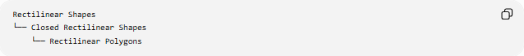
Rectilinear Shapes
└── Closed Rectilinear Shapes
└── Rectilinear Polygons
The sides are arranged in perpendicular directions.
Examples include:
- Rectangle
- Square
- L-shaped polygon
- T-shaped polygon
- U-shaped polygon
- Step-shaped polygon

Interior Angles
# Source: AI Source: Provided by: [Data Path: Persons Table -> ID Column: 1, Name_En Column: Motasem Essam] -> From: [ChatGPT] on [7/25/2026]
For a simple rectilinear polygon, every interior angle is either:
$${90}^{∘}$$
or
$${270}^{∘}$$
Convex vertex
$$\boxed{{90}^{∘}}$$
Concave vertex
$$\boxed{{270}^{∘}}$$
This provides a useful way to identify rectilinear polygons.

Number of Convex and Concave Vertices
# Source: AI Source: Provided by: [Data Path: Persons Table -> ID Column: 1, Name_En Column: Motasem Essam] -> From: [ChatGPT] on [7/25/2026]
For a simple rectilinear polygon with:
- $C$convex vertices
- $R$reflex (concave) vertices
the relationship is:
$$\boxed{C=R+4}$$
Therefore:
$$\boxed{R=C-4}$$
For example, if a rectilinear polygon has 3 concave vertices:
$$C=3+4=7$$
So it has:
- 7 convex vertices
- 3 concave vertices
- 10 vertices in total

Perimeter
# Source: AI Source: Provided by: [Data Path: Persons Table -> ID Column: 1, Name_En Column: Motasem Essam] -> From: [ChatGPT] on [7/25/2026]
The perimeter of a rectilinear shape is the sum of all its boundary segments.
$$\boxed{P=s_{1}+s_{2}+s_{3}+⋯+s_{n}}$$
For example:
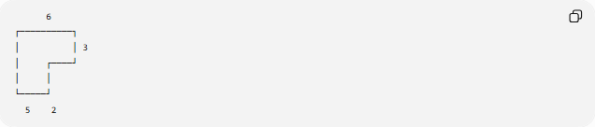
6
┌──────────┐
│ │ 3
│ ┌────┘
│ │
└─────┘
5 2
The perimeter is obtained by adding every boundary segment.
A useful property of closed rectilinear shapes is that:
$$\text{Total horizontal length to the right}=\text{Total horizontal length to the left}$$
and similarly:
$$\text{Total vertical length upward}=\text{Total vertical length downward}$$
This is useful when calculating missing side lengths.

Area
# Source: AI Source: Provided by: [Data Path: Persons Table -> ID Column: 1, Name_En Column: Motasem Essam] -> From: [ChatGPT] on [7/25/2026]
The area of an irregular rectilinear shape can often be found by dividing it into rectangles.
For example:
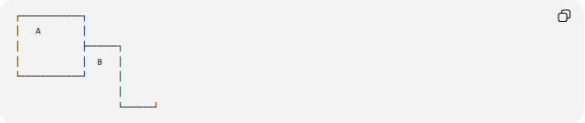
┌────────────┐
│ A │
│ ├──────┐
│ │ B │
└────────────┘ │
│
└──────┘
Then:
$$A_{\text{total}}=A_{A}+A_{B}$$
Alternatively, an enclosing rectangle can be used:
$$A_{\text{shape}}=A_{\text{large rectangle}}-A_{\text{removed rectangle}}$$
This makes rectilinear shapes particularly convenient for elementary area calculations.

Rectilinear Shapes vs Curvilinear Shapes
# Source: AI Source: Provided by: [Data Path: Persons Table -> ID Column: 1, Name_En Column: Motasem Essam] -> From: [ChatGPT] on [7/25/2026]
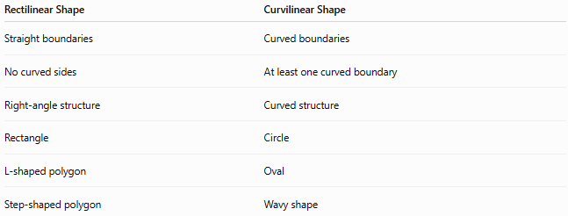
Rectilinear Shape | Curvilinear Shape
Straight boundaries | Curved boundaries
No curved sides | At least one curved boundary
Right-angle structure | Curved structure
Rectangle | Circle
L-shaped polygon | Oval
Step-shaped polygon | Wavy shape
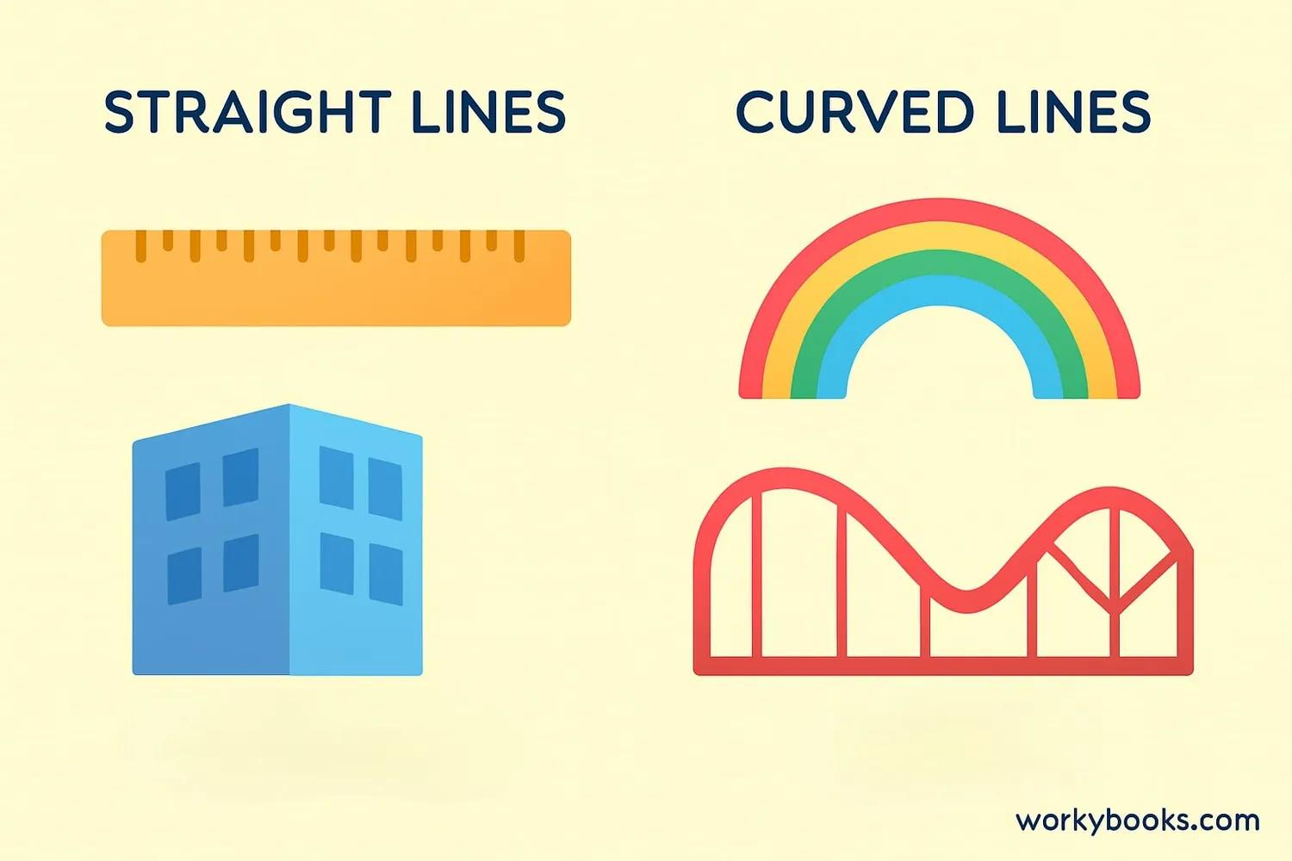
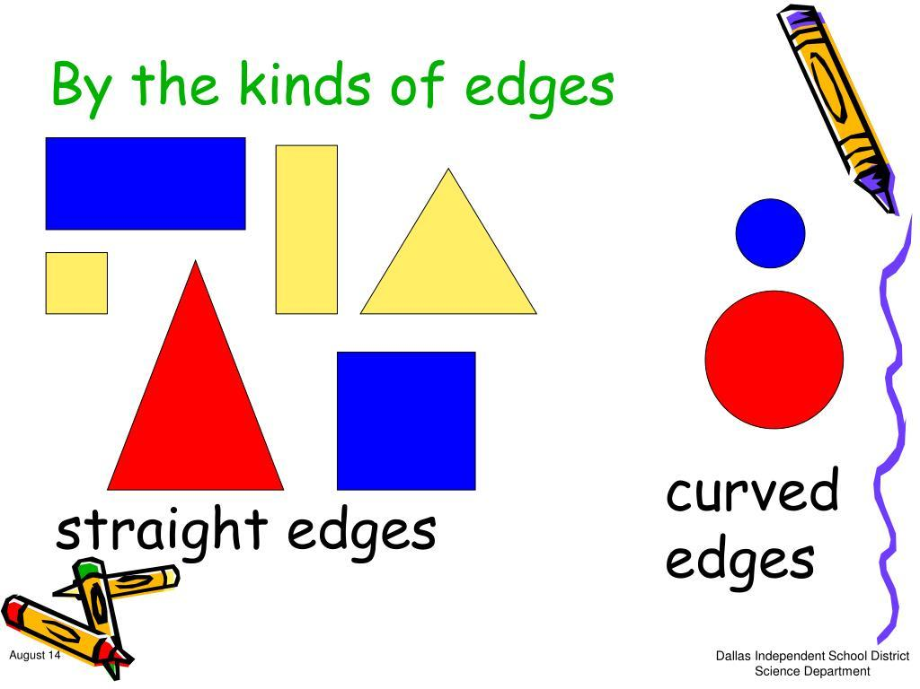
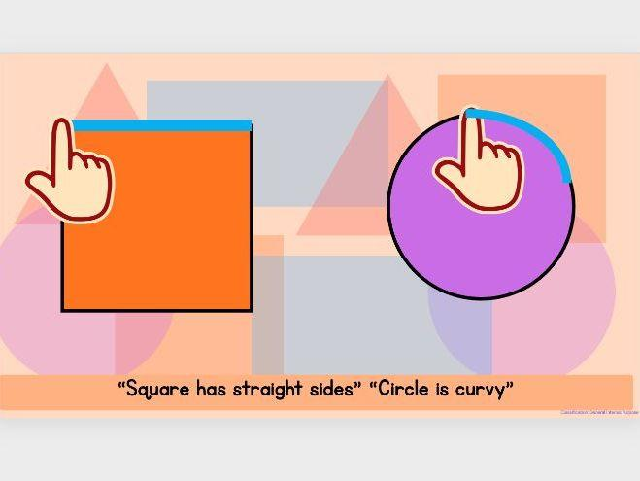
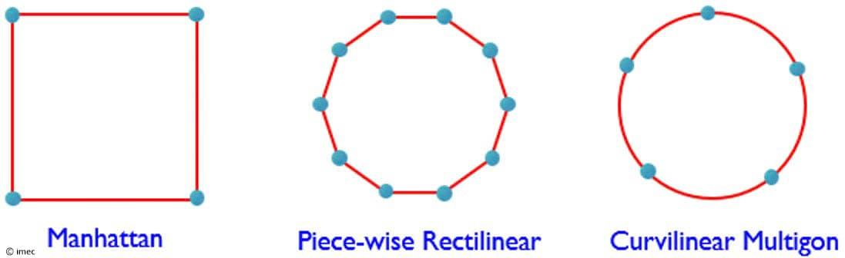

Rectilinear Shapes vs Zigzag Shapes
# Source: AI Source: Provided by: [Data Path: Persons Table -> ID Column: 1, Name_En Column: Motasem Essam] -> From: [ChatGPT] on [7/25/2026]
These terms describe different properties.
A zigzag shape is characterized by repeated changes in direction.
A rectilinear shape is characterized by straight boundaries meeting at right angles.
Therefore, a zigzag pattern can be rectilinear if all of its turns are right-angle turns.
However, a zigzag whose angles are not ${90}^{∘}$is not necessarily rectilinear.

Classification Summary
# Source: AI Source: Provided by: [Data Path: Persons Table -> ID Column: 1, Name_En Column: Motasem Essam] -> From: [ChatGPT] on [7/25/2026]
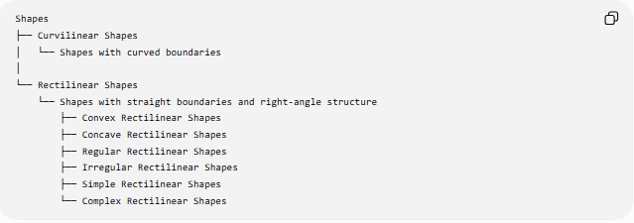
Shapes
├── Curvilinear Shapes
│ └── Shapes with curved boundaries
│
└── Rectilinear Shapes
└── Shapes with straight boundaries and right-angle structure
├── Convex Rectilinear Shapes
├── Concave Rectilinear Shapes
├── Regular Rectilinear Shapes
├── Irregular Rectilinear Shapes
├── Simple Rectilinear Shapes
└── Complex Rectilinear Shapes
For closed shapes:
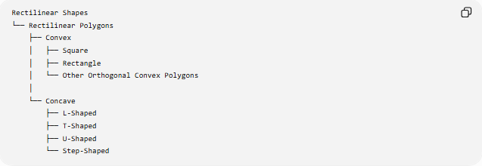
Rectilinear Shapes
└── Rectilinear Polygons
├── Convex
│ ├── Square
│ ├── Rectangle
│ └── Other Orthogonal Convex Polygons
│
└── Concave
├── L-Shaped
├── T-Shaped
├── U-Shaped
└── Step-Shaped

Key Points
# Source: AI Source: Provided by: [Data Path: Persons Table -> ID Column: 1, Name_En Column: Motasem Essam] -> From: [ChatGPT] on [7/25/2026]
- A Rectilinear Shape has a boundary made entirely of straight line segments.
- Its boundary follows perpendicular horizontal and vertical directions.
- Its vertices generally have interior angles of ${90}^{∘}$or ${270}^{∘}$.
- It can be convex or concave.
- It can be regular or irregular, although "regular rectilinear shape" is not a common formal category.
- A closed rectilinear shape is commonly called an orthogonal polygon or rectilinear polygon.
- Squares and rectangles are important examples.
- L-shaped, T-shaped, U-shaped, and step-shaped figures are common concave examples.
- Rectilinear shapes are especially useful for perimeter and area calculations because they can often be decomposed into rectangles.

Conclusion
# Source: AI Source: Provided by: [Data Path: Persons Table -> ID Column: 1, Name_En Column: Motasem Essam] -> From: [ChatGPT] on [7/25/2026]
A Rectilinear Shape is a shape whose boundary consists of straight segments arranged in perpendicular directions. It forms an important class of geometric shapes that includes simple figures such as squares and rectangles as well as complex L-, T-, U-, and step-shaped polygons.

